
Semester Two Examination, 2020

Question/Answer Booklet

MATHEMATICS

SOLUTIONS
METHODS
ATAR Year 12
Section One:
Calculator-free

Student Name: ______________________________________________________

Please circle your teacher’s name
Teacher: Miss Long Miss Rowden Ms Stone

Time allowed for this paper
Reading time before commencing work: 5 minutes
Working time for paper: 50 minutes

Materials required/recommended for this paper
To be provided by the supervisor
Number of additional
answer booklets used
(if applicable):
This Question/Answer Booklet
Formula Sheet

To be provided by the candidate
Standard items: pens (blue/black preferred), pencils (including coloured), sharpener, correction fluid/tape, eraser, ruler, highlighters

Special items: nil

Important note to candidates
No other items may be taken into the examination room. It is your responsibility to ensure that you do not have any unauthorised material. If you have any unauthorised material with you, hand it to the supervisor before reading any further.
Structure of this paper
Section | Number of questions available | Number of questions to be answered | Suggested working time (minutes) | Marks available | Percentage of examination
Section One:  Calculator free | 8 | 8 | 50 | 52 | 35
Section Two:  Calculator-assumed | 13 | 13 | 100 | 98 | 65
 |  |  |  | Total | 100

Instructions to candidates
- The rules for the conduct of the ATAR course examinations are detailed in the Year 12 Information Handbook 2020. Sitting this examination implies that you agree to abide by these rules.

- Write your answers in this Question/Answer booklet.

- You must be careful to confine your answers to the specific questions asked and to follow any instructions that are specific to a particular question.

- Supplementary pages for the use planning/continuing your answer to a question have been provided at the end of the Question/Answer booklet. If you use these pages to continue an answer, indicate at the original answer where the answer is continued, i.e. give the page number.

- Show all your working clearly. Your working should be in sufficient detail to allow your answers to be checked readily and for marks to be awarded for reasoning. Incorrect answers given without supporting reasoning cannot be allocated any marks. For any question or part question worth more than two marks, valid working or justification is required to receive full marks. If you repeat any question, ensure that you cancel the answer you do not wish to have marked.

- It is recommended that you do not use pencil, except in diagrams.

- The Formula sheet is not to be handed in with your Question/Answer booklet.

Section One: Calculator-free 35% (52 Marks)

This section has eight (8) questions. Answer all questions. Write your answers in the spaces
provided.

Supplementary pages for the use of planning/continuing your answer to a question have been provided at the end of this Question/Answer booklet. If you use these pages to continue an answer, indicate at the original answer where the answer is continued, i.e. give the page number.

Working time: 50 minutes.

Question 1 (7 marks)
(a) Determine an expression for $f'(x)$ when

(i) $f\left(x\right)=\ln\left(1-\cos{3x}\right)$. (2 marks)
Solution
$$f^{'}\left(x\right)=\frac{3\sin{3x}}{1-\cos{3x}}$$

Specific behaviours
numerator
✓ denominator

(ii) $f\left(x\right)=e^{5x}{\left(5-2x\right)}^{3}$. (3 marks)
Solution
$$f^{'}\left(x\right)=5e^{5x}{\left(5-2x\right)}^{3}+e^{5x}∙3\left(-2\right){\left(5-2x\right)}^{2}$$
$$=5e^{5x}{\left(5-2x\right)}^{3}-6e^{5x}{\left(5-2x\right)}^{2}$$

N.B. Simplifies to $\left(19-10x\right){\left(5-2x\right)}^{2}e^{5x}$
Specific behaviours
✓ derivative of $e^{5x}$
✓ derivative of ${\left(5-2x\right)}^{3}$
✓ correct expression using product rule

(b) For the positive number $x$, let $A\left(x\right)=\int_{0}^{x}{\underset{ }{\overset{ }{(8-2^{t^{2}})}}}dt$.
Determine the value(s) of $x$ for which $\begin{matrix}dA \\ \overline{dx}\end{matrix}=0$. (2 marks)
Solution
$$\frac{dA}{dx}=\frac{d}{dx}\int_{0}^{x}{(8-{2^{t}}^{2})}dt \\ =8-2^{x^{2}}$$

$$∴2^{x^{2}}=8=2^{3}⇒x^{2}=3⇒x=\sqrt{3}$$

Specific behaviours
expression for $A'(x)$
✓ correct value of $x$

Question 2 (7 marks)
The discrete random variable $X$ is defined by
$$P\left(X=x\right)=\left\{\begin{matrix}\frac{x+b}{5x+2} & x=0, 1 \\ & \\ 0 & \text{elsewhere}\end{matrix}\right.$$
(a) Determine the value of the constant $b$. (2 marks)
Solution
$$\frac{b}{2}+\frac{1+b}{7}=1 \\ 7b+2+2b=14 \\ b=\frac{4}{3}$$

Specific behaviours
forms equation using $x=0$ and $x=1$
✓ correct value

(b) Determine

(i) $P(X=0)$. (1 mark)
Solution
$$P\left(X=0\right)=\frac{4}{3}÷2=\frac{2}{3}$$

Specific behaviours
correct probability

(ii) $E(7X-3)$. (2 marks)
Solution
$$E\left(X\right)=p=P\left(X=1\right)=1-\frac{2}{3}=\frac{1}{3} \\ E\left(7X-3\right)=7×\frac{1}{3}-3=-\frac{2}{3}$$

Specific behaviours
indicates $E(X)$
✓ correct value

(iii) $\operatorname{Var}{(7X-3)}$. (2 marks)
Solution
$$\operatorname{Var}\left(X\right)=p\left(1-p\right)=\frac{1}{3}×\frac{2}{3}=\frac{2}{9} \\ \operatorname{Var}\left(7X-3\right)=7^{2}×\frac{2}{9}=\frac{98}{9}$$

Specific behaviours
indicates $\operatorname{Var}{(X)}$
✓ correct value

Question 3 (5 marks)
The rate of change of pressure in an air tank is given by $P^{'}\left(t\right)=-3e^{-0.05t}$, where $t$ is the
time in in minutes since it began to empty.
(a) Determine an expression for the pressure $P$ in the tank at any time $t, t≥0$. (2 marks)
Solution
$$P\left(t\right)=\frac{-3}{-0.05}e^{-0.05t}+c \\ =60e^{-0.05t}+c$$

$$\left(0, 70\right)⇒70=60e^{0}+c \\ c=10$$

$$P\left(t\right)=10+60e^{-0.05t}$$

Specific behaviours
correctly integrates $P'(t)$
✓ correct expression for $P(t)$

(b) Determine

(i) the time taken for the pressure in the tank to fall to $40$ psi. (2 marks)
Solution
$$10+60e^{-0.05t}=40 \\ e^{-0.05t}=0.5$$

$$-0.05t=\ln{0.5} \\ t=-20\ln{0.5} (=20\ln{2})$$

Specific behaviours
simplifies equation to $e^{-0.05t}=k$
✓ correct time

(ii) the minimum pressure in the tank for $t≥0$. (1 mark)
Solution
$$t→∞, P→10 \text{psi}$$

Specific behaviours
correct pressure

Question 4 (6 marks)
The continuous random variable $X$ takes values in the interval $3$ to $8$ and has cumulative distribution function $F(x)$ where
$$F\left(x\right)=P\left(X≤x\right)=\left\{\begin{matrix}0 & x<3 \\ \begin{matrix}x-3 \\ \overline{ 5 }\end{matrix} & 3≤x≤8 \\ 1 & x>8.\end{matrix}\right.$$
(a) Determine

(i) $P(X≤4.5)$. (1 mark)
Solution
$$P\left(X≤4.4\right)=\frac{4.5-3}{5}=\frac{1.5}{5}=\frac{3}{10}=0.3$$

Specific behaviours
correct probability

(ii) the value of $k$, if $P\left(X>k\right)=0.75$. (2 marks)
Solution
$$P\left(X≤k\right)=1-P\left(X>k\right)=1-0.75=0.25$$

$$\frac{k-3}{5}=0.25⇒k=4.25$$

Specific behaviours
indicates $P\left(X≤k\right)$
✓ correct value

(b) Determine $f(x)$, the probability density function of $X$, and sketch the graph of $y=f(x)$.
(3 marks)
Solution
$$f\left(x\right)=F^{'}\left(x\right)=\left\{\begin{matrix}\frac{1}{5} & 3≤x≤8 \\ 0 & \text{elsewhere}\end{matrix}\right.$$

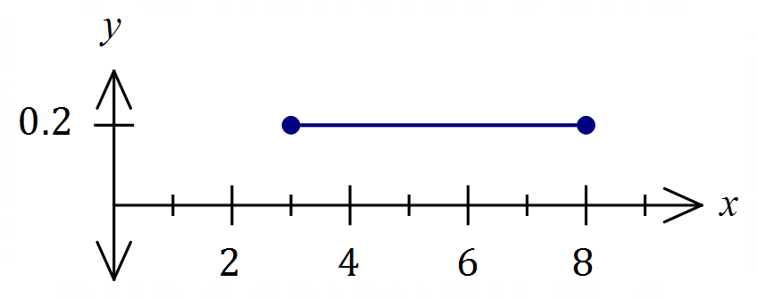

Specific behaviours
$f(x)$ (no penalty for just $f\left(x\right)=\frac{1}{5}$ if sketch correct)
✓ draws $y=0.2$ between endpoints
✓ scaled and labelled axes

Question 5 (7 marks)
The function $f$ is defined by $f\left(x\right)=\begin{matrix}x^{2}-7 \\ \overline{ 4-x }\end{matrix}, x≠4$.
The second derivative of $f$ is $f^{''}\left(x\right)=18{\left(4-x\right)}^{-3}$.
Determine the coordinates and nature of all stationary points of the graph of $y=f(x)$.
Solution
$$f^{'}\left(x\right)=\frac{2x\left(4-x\right)-(-1)(x^{2}-7)}{{\left(4-x\right)}^{2}}$$

$$f^{'}\left(x\right)=0⇒8x-2x^{2}+x^{2}-7=0 \\ \left(x^{2}-8x+7\right)=0 \\ \left(x-1\right)\left(x-7\right)=0 \\ x=1, 7$$

$$f^{''}\left(1\right)=\frac{18}{3^{3}}>0⇒\text{Min}, f^{''}\left(7\right)=\frac{18}{-3^{3}}<0⇒\text{Max}$$

$$f\left(1\right)=-\frac{6}{3}=-2, f\left(7\right)=\frac{42}{-3}=-14$$

$f(x)$ has a minimum at $(1, -2)$ and a maximum at $(7, -14)$.

Specific behaviours
indicates correct use of quotient rule
✓ correct $f'(x)$
✓ equates numerator to zero
✓ determines $x$-coordinates of stationary points
✓ indicates correct use of second derivative for nature
✓ correct minimum
✓ correct maximum

Question 6 (7 marks)
(a) Simplify $3\log{20}-\log{4}+\log{5}$. (2 marks)

Solution
$$\log{{20}^{3}}-\log{4}+\log{5}=\log\left(8000÷4×5\right) \\ =\log{{10}^{4}} \\ =4$$

Specific behaviours
expresses as single log
✓ simplifies to number

(b) Given that $\log_{a}{x}=0.82$, determine the value of $\log_{a}\left(\begin{matrix}\sqrt{x} \\ \overline{ x }\end{matrix}\right)$. (2 marks)
Solution
$$\log_{a}{\frac{\sqrt{x}}{x}}=\log_{a}{\sqrt{x}}-\log_{a}{x} \\ =0.5\log_{a}{x}-\log_{a}{x}$$
$$=-0.5\log_{a}{x} \\ =-0.5×0.82 \\ =-0.41$$

Specific behaviours
obtains multiple of $\log_{a}{x}$
✓ correct value

(c) Determine the solution to the equation $2^{3x}=5^{2-x}$ in the form $x=\begin{matrix}\log{a} \\ \overline{\log{b}}\end{matrix}$ . (3 marks)
Solution
$$3x\log{2}=\left(2-x\right)\log{5} \\ 3x\log{2}=2\log{5}-x\log{5} \\ 3x\log{2}+x\log{5}=2\log{5} \\ x\left(3\log{2}+\log{5}\right)=2\log{5} \\ x=\frac{\log{5^{2}}}{\log{{(2}^{3}×5)}} \\ x=\frac{\log{25}}{\log{40}}$$

Specific behaviours
writes as log equation
✓ factors out $x$
✓ solves and simplifies into required form

Question 7 (6 marks)
The acceleration at time $t$ seconds of a small body travelling in a straight line is given by
$$a\left(t\right)=\frac{-27}{\sqrt{3t+1}} {\text{cm/s}}^{2}, t≥0.$$
When $t=1$ the body was at the origin and $7$ seconds later its displacement was $22$ cm.
Determine the velocity of the body when $t=5$.
Solution
$$v\left(t\right)=\int{-27{\left(3t+1\right)}^{-\frac{1}{2}}}dt \\ =\frac{-27}{\frac{1}{2}×3}{\left(3t+1\right)}^{\frac{1}{2}}+c \\ =-18{\left(3t+1\right)}^{\frac{1}{2}}+c$$

$$Δx=\int_{1}^{1+7}{-18{\left(3t+1\right)}^{\frac{1}{2}}+c}dt \\ ={\left[\frac{-18}{\frac{3}{2}×3}{\left(3t+1\right)}^{\frac{3}{2}}+ct\right]}_{1}^{8} \\ ={\left[-4{\left(3t+1\right)}^{\frac{3}{2}}+ct\right]}_{1}^{8} \\ =\left[-4(125)+8c\right]-\left[-4(27)+c\right] \\ =7c-468$$
But $Δx=22$
$$7c-468=22 \\ 7c=490 \\ c=70$$

$$v\left(5\right)=-18{\left(3(5)+1\right)}^{\frac{1}{2}}+70 \\ =-72+70 \\ =-2 \text{cm/s}$$

Specific behaviours
antiderivative of $a(t)$
✓ integral for change in displacement $Δx$
✓ antiderivative of $v(t)$
✓ simplifies equation for $c$
✓ uses given $Δx$ to determine value of $c$
✓ correct velocity

Question 7 – alternative method
Solution
$$v\left(t\right)=\int{-27{\left(3t+1\right)}^{-\frac{1}{2}}}dt \\ =\frac{-27}{\frac{1}{2}×3}{\left(3t+1\right)}^{\frac{1}{2}}+c \\ =-18{\left(3t+1\right)}^{\frac{1}{2}}+c$$

$$x\left(t\right)=\int{-18{(3t+1)}^{\frac{1}{2}}}dt \\ =\frac{-18}{\frac{3}{2}×3}{\left(3t+1\right)}^{\frac{3}{2}}+ct+k \\ =-4{\left(3t+1\right)}^{\frac{3}{2}}+ct+k$$
$$0=-4{\left(3×1+1\right)}^{\frac{3}{2}}+1c+k$$$32=c+k$ eqn
$$22=-4{\left(3×8+1\right)}^{\frac{3}{2}}+8c+k \\ 522=8c+k$$
$$7c=490 \\ c=70$$

$$v\left(5\right)=-18{\left(3(5)+1\right)}^{\frac{1}{2}}+70 \\ =-72+70 \\ =-2 \text{cm/s}$$

Specific behaviours
antiderivative of $a(t)$
✓ antiderivative of $v(t)$
✓ $x\left(t\right)$ equation for $t=1$
$x\left(t\right)$ equation for $t=8$
✓ solves simultaneously to determine value of $c$
✓ correct velocity

Question 8 (7 marks)
The graph and a table of values for $y=f(x)$ is shown below, where $f\left(x\right)=\sin{x}$.
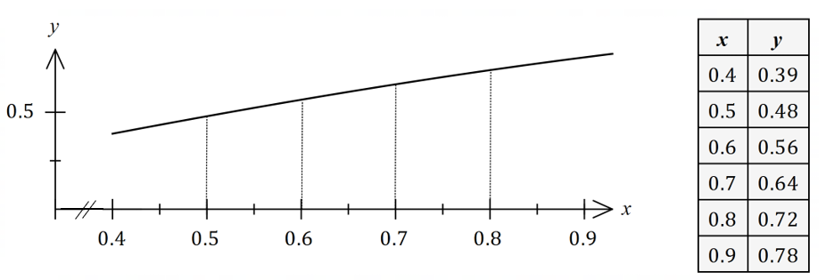
Let $I=\int_{0.5}^{0.8}{\underset{ }{\overset{ }{\sin{x}}}}dx$.
(a) By using the information shown and considering sums of the form $\sum_{i}{f\left(x_{i}\right)δx_{i}}$ explain
why $I<0.192$.
(3 marks)
Solution
With $δx=0.1, x_{1}=0.6, x_{2}=0.7$ and $x_{3}=0.8$ then
$$Σ_{i}f\left(x_{i}\right)δx_{i}=0.1\left(0.56+0.64+0.72\right) \\ =0.1\left(1.92\right) \\ =0.192$$
Hence $I$ must be less than this value as it is the area of circumscribed rectangles that overestimate the area under the curve.
Specific behaviours
indicates $x$-ordinates for circumscribed rectangles
✓ shows sum of $f\left(x_{i}\right)δx_{i}$
✓ explains inequality

(b) In a similar manner to (a), determine the lower estimate,$L$, for the value of $I$.
That is, the value of $L$ for $I>L$.
(2 marks)
Solution
With $δx=0.1, x_{1}=0.5, x_{2}=0.6$ and $x_{3}=0.7$ then
$$L=Σ_{i}f\left(x_{i}\right)δx_{i}=0.1\left(0.48+0.56+0.64\right) \\ =0.1\left(1.68\right) \\ =0.168$$

Specific behaviours
indicates $x$-ordinates for inscribed rectangles
✓ value of $L$

(c) Use your previous answers to determine a numerical estimate for $I$ and explain whether your estimate is smaller or larger than the exact value of $I$. (2 marks)
Solution
$$I=\frac{0.168+0.192}{2}=0.18$$
This value slightly underestimates the exact value of $I$ as the curve is concave downwards.

Specific behaviours
correctly averages values
✓ states underestimate with reason

